Design Your Own Currency
Grade 5/6 Art | Design Your Own Currency | Money Sense
Name: ______________________________ Date: ________________
You are the chief designer for the bank of a brand new country. Design its first banknote on your 16 x 24 sheet of coloured paper. Turn it sideways (like most money) or stand it up tall (vertical, like Canada's new notes).
Golden rules
• Invent your own country and money. Never copy a real banknote.
• Use your own original symbols. Do not copy First Peoples designs or crests; some are sacred and shared only with permission.
• Plan small first on your planning sheet, then go big.

Requirements checklist: tick each box when it is done. The numbers match the gold numbers on the exemplar (page 2).
WORDS AND NUMBERS
[ ] | 1 | Country name and bank name (Bank of ...)
[ ] | 2 | Denomination: the number in all 4 corners, plus the value written in words once
[ ] | 3 | A second language (French, or a language from your family) for the bank name or value
[ ] | 4 | Date of production: a series year (example: Series 2026)
[ ] | 5 | Two authorized signatures, each with a title (Governor, Deputy Governor)
[ ] | 6 | A serial number (2 letters + 7 numbers), shown twice
PICTURES AND SYMBOLS
[ ] | 7 | Portrait of a significant person in a frame, with their name (a hero, someone in your life, or invented)
[ ] | 8 | A significant place (a landmark or landscape)
[ ] | 9 | A significant thing (animal, plant, or object) that stands for an idea
[ ] | 10 | A national emblem or coat of arms you design, plus a motto
SECURITY AND ACCESS
[ ] | 11 | At least 2 security features: window, metallic strip, microprinting, fine-line pattern, or watermark
[ ] | 12 | Tactile dots (hole-punch dots or puffy paint) so a person who is blind can feel the value
ART SKILLS
[ ] | 13 | A border with a repeating pattern around the whole edge
[ ] | 14 | A colour scheme: 2 or 3 main colours that work with your paper
[ ] | 15 | A focal point and balance: one thing the eye sees first; space evenly filled
[ ] | 16 | Fine line work: hatching or crosshatching to shade the portrait, like an engraving
SHARE
[ ] | 17 | Designer statement (exit ticket): explain your symbols and one art choice
Challenges: design the back of your note too. Grade 6: set an exchange rate (1 of your currency = ? Canadian dollars) and price 3 Dice Shop items in your money.

Annotated exemplar: Republic of Huckleberry, 50 Huckles
Each gold number matches a checklist item on page 1. Yours will look different. That is the point!
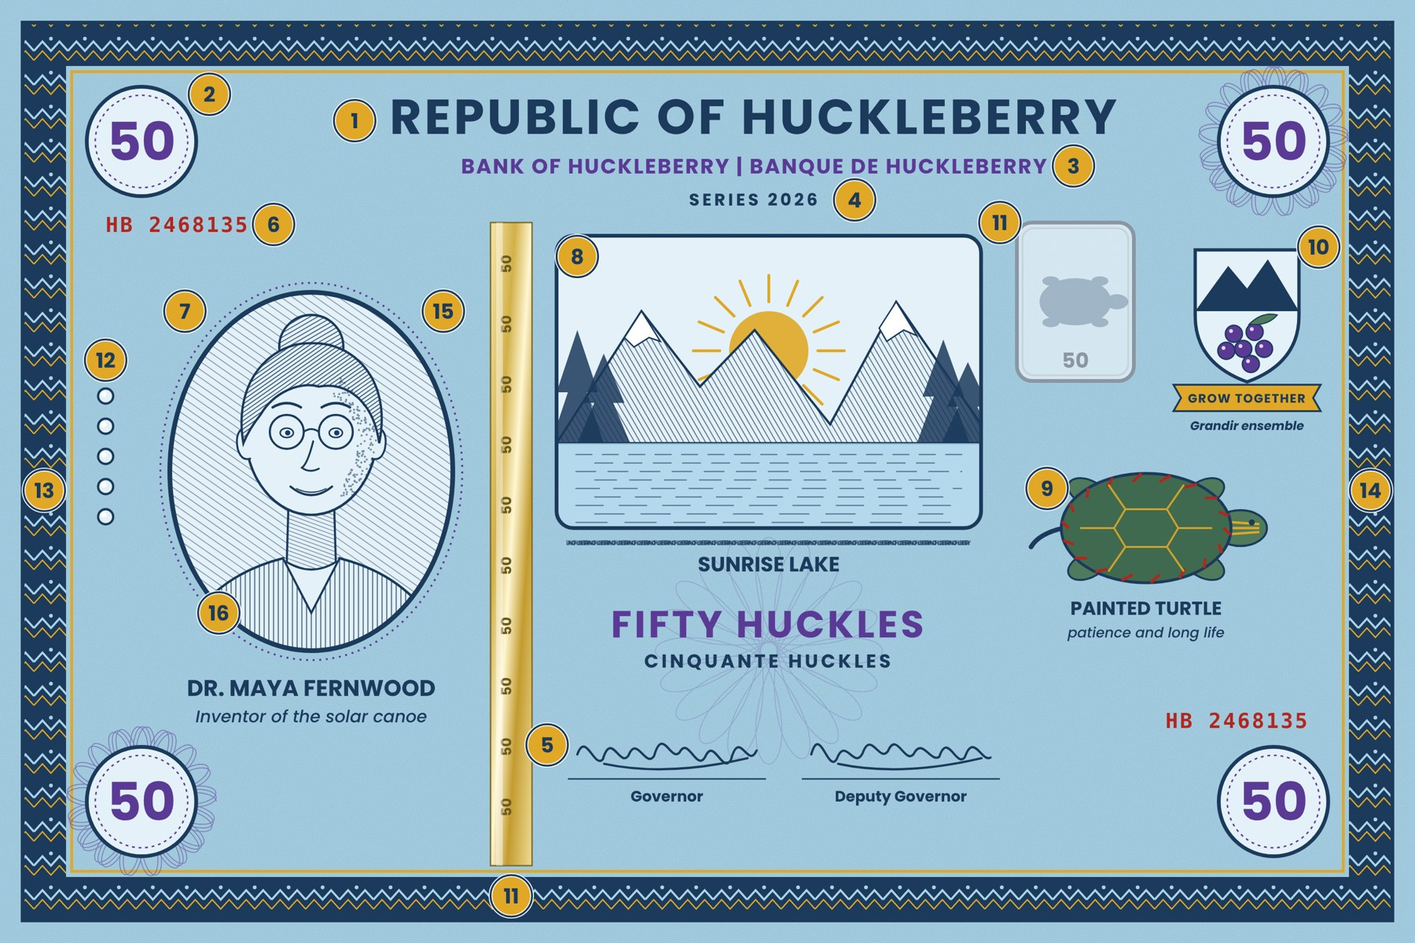
Model designer statement
My country is the Republic of Huckleberry. The 50 Huckle note honours Dr. Maya Fernwood, who invented a solar canoe, because my country values clean energy. Sunrise Lake is the place everyone shares. The painted turtle stands for patience. I used blue and purple so the 50 is easy to spot, and the portrait is my focal point.
Where good ideas come from
• Person: a hero, an inventor, an athlete, an Elder or grandparent, a community helper, or someone you invent.
• Place: a lake, mountain, park, school, or a place your family loves.
• Thing: an animal, plant, food, or object that stands for an idea (a turtle for patience).

